STOCK MARKET PREDICTION USING LASSO REGRESSION
(Shivani Patel, Faizan Abbas)

ABSTRACT
Accurate prediction of stock market returns is a very challenging task due to the volatile and non-linear nature of the financial stock markets. Stock market prediction is crucial in finance, enabling informed decisions based on forecasts of stock prices. This paper explores the application of Machine Learning (ML) techniques using Python to predict stock closing prices. The dataset sourced from Yahoo Finance (yahoo_data.xlsx) includes historical stock data, encompassing daily metrics such as opening, highest, lowest prices, and trading volumes. The system is developed by a machine learning algorithm such as lasso regression. The models are evaluated using standard strategic indicators: RMSE (Root Mean Squared Error) and MAE (Mean Absolute Error). The low values of these two indicators show that the models are efficient in predicting stock closing prices.

GOAL
The goal of this project is to develop a predictive model using Lasso Regression to forecast stock market prices. This involves analyzing historical stock data from Yahoo Finance to understand trends and patterns, and using this information to make informed predictions about future stock prices.

DATASET
The dataset consists of historical stock market data sourced from Yahoo Finance, including:
- Open: Opening price of the stock for the day.
- High: Highest price of the stock for the day.
- Low: Lowest price of the stock for the day.
- Volume: Volume of stocks traded during the day.
- Close*: Closing price of the stock for the day (target variable).

IMPLEMENTATION

Figure: Flow Chart

FEATURE ENGINEERING
Feature engineering is a crucial step in stock market prediction using machine learning. It involves creating meaningful input features from raw data to help the model better understand and capture the complexities of market dynamics.Some key aspects of feature engineering for stock market prediction include:
Data Preprocessing:
- Cleaning and preparing historical stock data to ensure quality and reliability
- Handling missing data points, detecting and addressing outliers, and normalizing data to a consistent scale
Feature Selection:
- Identifying the most important features that impact stock prices
- Commonly used techniques include correlation criteria, random forest, recursive feature elimination (RFE), and principal component analysis (PCA)
Feature Extraction:
- Breaking down raw data into informative time series representations that hint at expected future values.

TRAIN TEST SPLIT
The dataset will be split into training and testing sets. Typically, 70-80% of the data will be used for training, and the remaining 20-30% will be used for testing. This ensures that the model is evaluated on unseen data to assess its performance.

MODEL
The model used for this project will be Lasso Regression. Lasso Regression is a linear regression technique that includes an L1 regularization term to prevent overfitting and handle multicollinearity by shrinking some coefficients to zero.

TEST
The model's performance is tested by making predictions on the test set (X_test) derived from the split dataset.

EVALUATION
The evaluation phase involves analyzing the performance metrics obtained during testing to understand the model's accuracy by using the following metrics:
- Mean Absolute Error (MAE)
- Mean Squared Error (MSE)
- Root Mean Squared Error (RMSE)
- R-squared (R²) score
These metrics provide insights into how well the model predicts the closing prices compared to the actual values.

VISUALIZATION
Visualization plays a crucial role in understanding the results. Key visualizations will include:
- Actual vs Predicted Prices
- Error Analysis plots
- Coefficient Paths (showing the effect of regularization)
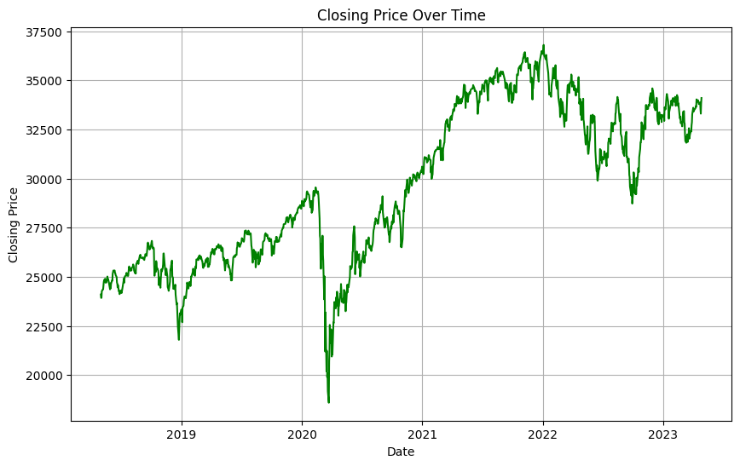

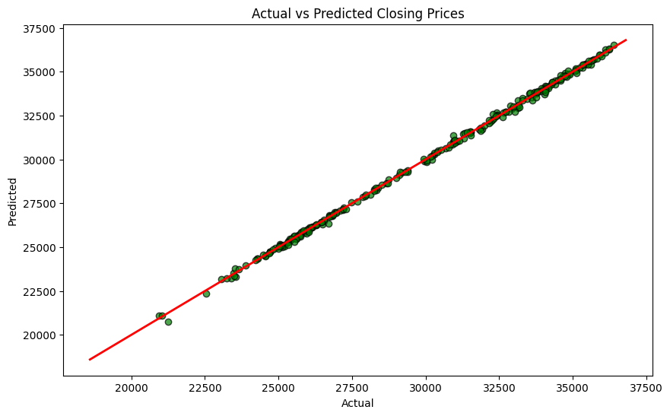
FUTURE SCOPE
For future reference PyTorch can be used.Using PyTorch for stock market prediction offers a wide range of future scopes and opportunities. Here are some areas where PyTorch can be leveraged for advancing stock market prediction:
- Deep Learning Models
- Recurrent Neural Networks (RNNs)
- Convolutional Neural Networks (CNNs)
- Hybrid Models
- Combining LSTM and CNN to capture both sequential dependencies and local patterns in stock price data.
- Adding attention layers to RNNs or LSTMs to focus on important time steps.

JUSTIFICATION
Why Lasso Regression?
Lasso Regression was selected for its ability to handle multicollinearity, perform feature selection, and prevent overfitting while maintaining model interpretability. These characteristics make it a robust choice for stock market prediction using the given dataset from Yahoo Finance.

Why Not Other Regression Models?
Lasso regression provides regularization which gives it an upper hand on other regression technique. Studies have also shown that lasso regression model tend to outperform other regression techniques.
RESULT AND CONCLUSION
In our project, lasso regression is used to predict the stock market prices. The stock price dataset was processed using the LASSO Regression type of linear regression algorithm, with input from the dataset repository. The data is then processed in the subsequent stage of data pre-processing. To prevent inaccurate predictions, we must deal with the missing values in this phase. The feature selection process then uses the Pearson coefficient to choose the finest features from our dataset. The data must then be divided into two categories, test data and train data. In this stage, the model is predicted by the test, and its performance is assessed by the train. Regression methods for machine learning, like lasso regression, are implemented.

DAILY WORK REPORT

Date | Activities Done
 | Faizan's Activities | Shivani's Activities
02/07/24 | - Gathered historical stock data. Checked for missing values. Converted 'Date' column. Selected features. Split dataset . | - Implemented Lasso Regression. Trained and evaluated performance.
03/07/24 | - Generated visualizations. Prepare Documentation . | - Model evaluation Created scatter plot. Finalized report.
04/07/24 | - Documentation project outcomes. Code also. | - Project code and visualization. Flowchart for project.

